**2. The Mongo Shell -** **Commands**

Contents

1. Using Eval 1

2. Executing Script Files. 3

3. Using the shell on a production system 3

4. External Editor Integration 4

5. Load Script from Within the Shell 5

# Using Eval

Stop MongoDB service

==============================

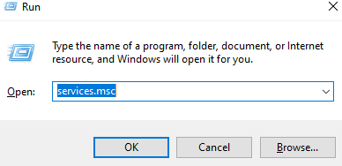

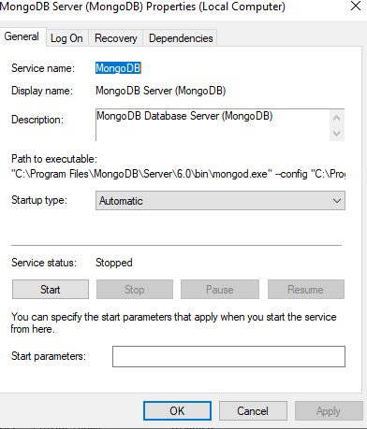

Start mongo daemon with configuration file

============================================

C:\Users\Admin> mongod -f C:\MyData\mongod.conf

Open another terminal

============================

C:\Users\Admin> cd C:\MyData

Ensure only one log file is present. Delete timestamped logs

======================================================

C:\MyData> dir /b *.log*

mongo-server.log

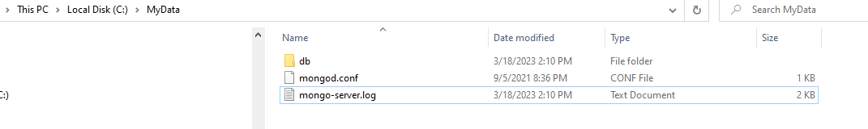

C:\MyData>mongosh localhost/admin --eval "db.adminCommand({ logRotate: 1 })"

***or***

C:\MyData>mongosh --host localhost --port 27017 --eval "db.adminCommand({ logRotate: 1 })"

***or***

C:\MyData>mongosh localhost/admin --eval "db.runCommand({ logRotate: 1 })"

Blah blah

………………..

………………..

{ ok: 1 }

C:\MyData>dir /b *.log*

mongo-server.log

mongo-server.log.2023-03-18T08-21-49

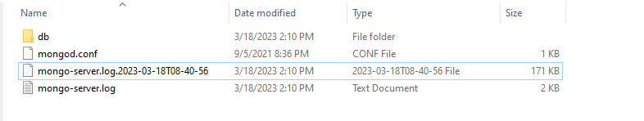

# Executing Script Files.

Copy userCount.js to C:\MyData

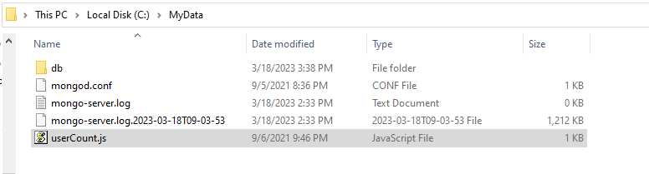 Run the userCount function

C:\MyData>mongosh userCount.js

Loading file: userCount.js

DeprecationWarning: Collection.count() is deprecated. Use countDocuments or estimatedDocumentCount.

Today's User Count: 1

# Using the shell on a production system

Prevent dropping a database accidentally in production

==========================================

Run a script and remain in the shell

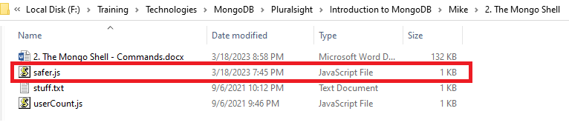

C:\MyData>mongosh mongosh –shell safer.js

Loading file: safer.js

test> db.dropDatabase()

Don't do it man!

# External Editor Integration

Exit the shell

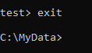

Open a new shell (Type in **mongosh**)

======================================

Declare and invoke stuff variable (**Open stuff.txt**)

=========================================

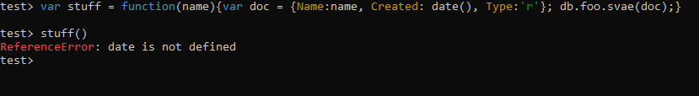

Exit the shell



SET environment variable for your preferred editor

=======================================

SET Editor=”C:\Program Files\EditPlus\editplus.exe”

SET Editor=”C:\”Program Files”\EditPlus\editplus.exe”

SET Editor=“c:\windows\notepad.exe”

Open a new shell (Type in **mongosh**)



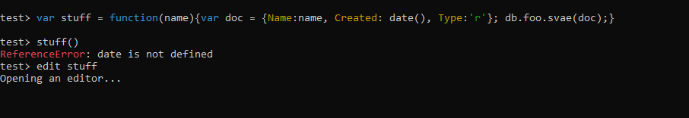

Inspect stuff



Invoke function stuff with some name

test> stuff('Bob')

# Load Script from Within the Shell

Check current directory

test> pwd()

ReferenceError: pwd is not defined (Are you trying to run a script written for the legacy shell? Try running `snippet install mongocompat`)

test> snippet install mongocompat

Running install...

Installed new snippets mongocompat. Do you want to load them now? [Y/n]: Y

Finished installing snippets: mongocompat

test> pwd()

C:\MyData

test> load('safer.js')

true

# User RC File

**Save file safer.js to C:\Users\{user_name} as .mongoshrc.js**

==================================================

test> exit

C:\MyData>mongosh

test> db.dropDatabase()

Don't do it man!

Disable rc file

test> exit

C:\MyData>mongosh –norc

test> use something

switched to db something

something> db.dropDatabase()

{ ok: 1, dropped: 'something' }

**********************************************************************************************************************************************